IMPLEMENTATION STEP 5

FORMING AN ENTERPRISE TO CREATE VALUE

In the previous stage of evaluation, we investigated whether your idea really does represent a business opportunity and what resources are required to launch it. The third stage is to make it happen. In this next step, we begin to launch the entrepreneurial venture and form the new business. The key is to lay foundations that meet your longer term objectives, not just the short term goal of getting into the market. This means you will need to ensure that not only does the enterprise create value but that you retain control of the value that you create.

Value

What is value?

Value means different things to different people depending on the context of their enterprise. For some it is another word for profit. For others, especially social entrepreneurs, it refers to the realisation of some social objective such as relieving homelessness in a particular location or reducing social exclusion. In other words, your definition of value will depend on your particular goals, objectives and outlook on life (see Step 1).

Value is sometimes also thought of in terms of what is left behind in your business once you are no longer personally involved in it.

In order to do this, you will need to think hard about the kind of enterprise your new venture will be. This will depend, to some extent, on the legal form and route to market entry you adopt. These will influence how you control and manage your resources to create value. You will also need to ensure you retain ownership of the value you create. This can be extremely important especially in businesses which depend on the transfer of information or ‘intangible assets’.

Business case link

Good new ideas and fledgling businesses need to be protected. To read how one young designer went about this, click here.

This Step consists of two main sections:

Section 1: Forming your business
Section 2: Controlling your Intellectual Property

We look at how you manage all your resources in more detail in Step
6.

Section 1: Forming your business

In order to create lasting value in your new enterprise, you are going to have to develop the right frameworks and structures in which to contain or support your creative ideas. These frameworks and structures need to be enabling but also allow you flexibility to be innovative where necessary.

Choosing your business structure involves lots of decisions. These include deciding whether to start up as a new venture, buy a business, or whether to franchise an existing concept. They also include whether to set up as a sole trader, limited company, partnership, or cooperative. The appropriate business form will be conditioned by the route you have selected – so we look at this aspect of business formation first.

Routes to market entry

Very often we think of the start-up as involving a brand new business built from scratch. In reality, of course, there are a variety of ways of beginning a new venture. These include buying an existing business or taking up a franchise.

Buying a business

Buying a business that is already established may be a lot less work than starting from scratch, but it could take a long, hard search to find the business that’s right for you. The DTI’s Business Link service has produced a guide that takes you through the steps of buying an existing business, including how to assess and value a business, looking after existing staff and where you can get professional help. To link to this guide click here.

Buying a franchise

Buying a franchise is another option to consider if you want to run your own business. Instead of setting up a business from scratch you use a proven business idea. Typically you will trade under the brand name of the company offering the franchise and they will provide help and support. Successful franchises have a much lower failure rate than completely new businesses, but running a franchise doesn’t suit everybody. The DTI’s Business Link service has also produced a guide that shows you how you can find the right franchise and highlights the key issues you need to consider. To link to this guide click here.

A franchise business can take different legal forms, the most common being sole traders, partnerships or limited companies. Your freedom to manage the business, as a franchisee, is limited by the terms of the agreement. For more details on this click here.

For further discussion of the franchise option take a look at the BBC Working Lunch article Off the shelf businesses. Other useful franchise links are:

- British Franchise Association
- Franchise Business
- Franchise Info
- Smarta.com
- Startups.co.uk

Introduction to legal structures

If you have decided to buy an existing business, it may be that you will be acquiring shares in a limited company, which will dictate your choice of legal form. Similarly, a franchisor may also prescribe the legal form that you adopt. The legal status of your business can have a significant effect on what you can and can’t do, how you can raise money, and the level of form-filling and bureaucracy that you will need to comply with.

Business case link

The success of Carol McKeown’s business Baby Ceylon means that she had to consider shifting the company from a sole trader to a limited company. To read more about why click here.

Choosing the right legal structure for your business

It is important to select the legal structure that best suits the way that you do business. There are several structures to choose from depending on your situation, and the structure you select will affect:

- the amount of tax and national insurance you pay
- the records and accounts that you have to keep
- your financial liability if the business runs into trouble
- how your business can raise money
- how management decisions are made about the business.

To understand the differences between the different legal structures and help you gauge which will suit your business needs best, take a look at the DTI’s Business Link guide Choose the right legal structure for your business.

Overview of legal structures

The main types of legal structure are:
Sole Trader

The advantages of being a sole trader include independence, ease of set up and running, and that all the profits go to you.

The disadvantages include a lack of support, unlimited liability and the fact that you are personally responsible for any debts run up by your business.

Partnership

One of the advantages of being in a partnership is the ease of set up and running. Also partners can bring a variety of skills and experience to the business.

The disadvantage are that problems can occur when there are disagreements between partners, there is unlimited liability and, as a partner, you are personally responsible for any debts incurred by the business.

Limited Liability Partnership (LLP)

LLPs retain the flexibility of a partnership as opposed to the rigid structure of a limited company, and your personal liability is limited. There is also no restriction on the number of members, but at least two must be ‘designated members’, who have extra legal responsibilities.

The formation of an LLP is more complex and costly than that of a partnership and problems can occur when there are disagreements between other members.

Limited Liability Company

A limited liability company provides reduced exposure to meeting the company’s debts. This means that your personal risk will be restricted to how much you invest in the business and any guarantees you have given in order to obtain financing. However, this type of company also brings a range of extra legal duties, including the maintenance of the company’s public records (e.g. accounts).

Community Interest Company

This is a legal structure that is similar to a limited company, but designed to allow social enterprises to use profits and assets for the benefit of the community. They are more lightly regulated than charities, but do not have the tax advantages of charitable status. However, charities can set up a CIC as a subsidiary. CICs can be limited by shares, by guarantee or can be a public limited company.

Franchise

The major advantage of a franchise is that it takes advantage of the success of an established business and support networks. Its disadvantage is that your freedom to manage the business is limited by the terms of the franchise agreement. Also franchisees often pay a share of their turnover to the franchiser, which brings down overall profits.

Social Enterprise

Social enterprises are businesses that trade for a social purpose and represent a diverse and growing range of business activity across the UK.

Business case link

After 10 years as the general manager of an office supplies company, in 2001 John Kerr decided that he wanted to run his own business. To read how he went about choosing the right legal structure for his business, click here.

Legal forms – in more detail

Set up as self-employed
Setting up as a self-employed sole trader is the simplest and quickest way to start a one-person business. There isn't much paperwork to do or registration fees to pay, record keeping and accounting is straightforward, and there are the benefits of being your own boss. Find out the consequences – and the legal requirements – of setting up as a sole trader in the DTI’s Business Link guide.
A BBC news article illustrates the dangers of not meeting your tax obligations if you are self-employed, click here.

Sole trader
Being a sole trader is the simplest way to run a one-person business, and does not involve paying any registration fees. Keeping records and accounts is straightforward, and you get to keep all the profits. But you are personally liable for any debts that your business runs up, which can make this a risky option for businesses that need a lot of investment. For further details look at this section of the DTI’s Business Link guide, click here.

Partnership
In a partnership, two or more people share the risks, costs, and responsibilities of being in business. Each partner is self-employed and takes a share of the profits. Usually, each partner shares in the decision-making and is personally responsible for any debts that the business runs up.
Unlike a limited company, a partnership has no legal existence distinct from the partners themselves. If one of the partners resigns, dies or goes bankrupt, the partnership must be dissolved.
A partnership is a relatively simple and flexible way for two or more people to own and run a business together. However, partners do not enjoy any protection if the business fails. For further details look at this section of the DTI’s Business Link guide, click here.

Set up and register a limited company
Before your business can begin operating as a limited company, it has to be registered with the Registrar of Companies (Companies House). Incorporation is the process by which a new or existing business is converted into a corporate body. The DTI’s Business Link guide looks at the requirements that different types of limited company must meet, and will help you understand the registration process. It focuses mainly on private companies limited by shares, but will also highlight some of the special requirements for public limited companies (PLCs) and private companies limited by guarantee. To access this guide click here.

Other legal forms
Other forms include the Limited Liability Partnership or a Social Enterprise.

Section 2: Controlling your Intellectual Property (IP)

One of the problems facing inventors and entrepreneurs is whether or not they should share their ideas with other people. In some cases, their ideas are so innovative and have such potential as business opportunities, that the best strategy is to ensure secrecy – and don’t tell anyone, if you can help it (or if you do, get them to sign non-disclosure agreements). However, as you will have already seen, successful new venture creation is highly dependent on your networking skills.

If you are going to create value in your business, you need to ensure ownership of the idea that creates value in the first place. This raises the issue of controlling your Intellectual Property (IP).

There are many useful Web sites dealing with Intellectual Property which you should familiarise yourself with. A good place to start is with the UK Intellectual Property Office. There are links to industry specific sites as well as the main categories of patent, trademark, design and copyright .

Intellectual property

Intellectual property (IP) is the concept of people owning their creativity and innovation in the same way that they can own physical property. The owner of a piece of intellectual property can control how it is used and reap any rewards from its use.
In some cases IP gives rise to protection for ideas but in other areas the idea needs to be more fully developed before protection can arise. It will often not be possible to protect IP and gain IP rights unless they have been applied for and granted, but some IP protection such as copyright arises automatically, without any registration, as soon as there is some form of record of what has been created.
There are 4 main types of IP:

- patents
- trade marks
- designs
- copyright.

Patents

Patents cover inventions of both new and improved products and processes. They are probably the most widely publicised and conventional form of protection. Patents are usually granted for up to 20 years. This gives the inventor a monopoly right for a limited period to stop others making, using or selling an invention without the permission of the inventor. In return, the inventor discloses the technical details of the patent to the Patent Office.

In the UK the patent is granted to the first applicant to file rather than to invent (unlike in the US). Patents are usually awarded 18 months after the initial application and cover the four first years from filing. Thereafter, the patent must be renewed annually. The disadvantage of publishing a patent is that the invention is made public. Large corporations pay people to scrutinize the patents filed for good ideas that they can develop.

Owning the patent is not a guarantee of protection from copying, as James Dyson found to his considerable cost. Hoover copied his new vacuum technology on the basis that he would not be able to afford to go to court. He did - in the States, and won!

Patent searches

Start your search with the British Library Business and IP Centre( a very useful resource for more general business information but particularly for IP) and follow the links to patent information.

You can check things that have been registered as patents through a free patent search engine provided by the European Patent Office (EPO). You can also search on the US Patent and Trademark Office (USPTO) website.

 Activity

Try doing a search now by following both the EPO and the USPTO links.

Patent Search Process

THE PATENT SEARCH PROCESS

A patent search should be approached methodically and logically. Here are the various stages of the process.

1. Describe the problem that the invention is trying to solve. Try to limit this to a maximum of four lines.

Example:
Lorry tyres contain steel bands (known as beads) to reinforce their side walls. In order to recycle scrap tyres, it is desirable to separate them from the rest of the tyre. These beads can have considerable value if they are undamaged.

2. What is the solution to this problem?

Example
Produce a machine that will separate the bead + sidewall rubber from the rest of the tyre in an undamaged state.

3. What are the novel features of this invention? If you find a patent or patents that contains these you will be unable to patent.

Example
The machine will debead the tyre using hydraulic power, that will drive a circular cutting cylinder through the tyre sidewalls, rather like a pastry cutter.

4. Make a list some keywords that come to mind. You will need to use the description of the problem, the solution to the problem and the novel features top provide you with ideas.

5. From the keywords, form a single sentence to describe the novel features of the invention.

6. Look at the keywords again and try to find synonyms for each keyword. Do any of your keywords have American spellings? For help with synonyms consult:
www.thesaurus.com or www.m-w.com or any dictionary web site.

7. Keep the keywords in groups, where each group is a list of keyword synonyms (or alternative spellings)

8. Find the USPTO search page – www.uspto.gov and follow the prompts to Advanced Search.

9. Select the best keyword from at least two columns and form a search query. Initially it is best to use the title and abstract fields.

10. The search engine will return all the patents that contain your keywords in the field(s) you selected. If more than fifteen patents are found, it is best to adjust the query to reduce the number.

11. Look at your results and examine the titles. Select the most relevant and read the patent abstract.

12. If the patent is relevant, view the front sheet, the drawings and look through the start of the specification.

13. If the reference is a primary or secondary reference, print the first page. YOU MUST KEEP A LOG OF ALL THE PATENTS THAT YOU REVIEW.

14. If your query does not turn up any primary or secondary references, revise your search query. By reading related patents, you may be able to improve and update your list of keywords.

15. Once you have located a primary or secondary reference, cross-reference using References Cited and Referenced by within the search engine.

16. To achieve a high standard of search you will need to perform an additional two levels of searching after a primary reference is located. Often at the third level of searching, references will start to be repeated.

17. Print complete copies of each primary reference.

18. Once you are satisfied with your search in the USPTO (remember that patent applications as well as issued patents must be examined), complete a similar exercise using the European patent Office search engine. This can be reached from http://gb.espacenet.com/

19. GOOD LUCK!

Source: Dr. Dave Edmondson, Kingston University

Business case links

To read about how Imran Hakim decides whether to apply for IP click here. He received funding for iTeddy on Dragons’ Den and is responsible for reviewing intellectual property from research at Manchester University.

A brief guide to applying for a patent

If you are thinking of applying for a patent you should not publicly disclose the invention before you file an application because this could be counted as prior publication of your invention. Any type of disclosure (whether by word of mouth, demonstration, advertisement or article in a journal), by the applicant or anyone acting for them, could prevent the applicant from getting a patent. It could also be a reason for having the patent revoked if one was obtained. It is essential that the applicant only makes any disclosure under conditions of strict confidence.

The basis of a UK patent application is a legal document called a specification. Its contents determine whether a patent can be granted. The Patent Office advises you to employ the services of a registered patent agent (or chartered patent agent), who will have the necessary technical and legal skills to prepare the specification. It is generally regarded to be easier to achieve commercial success with such help.

To file an application for a patent you should prepare a patent specification, including drawings if these are useful in describing the invention. The specification should contain a full description of your invention. It is absolutely vital that you put all the necessary information about your invention in the description. You cannot make any changes to your specification once you have filed your application.

For full details of how to apply for a patent in the UK visit IPO website, you can link to it now by clicking here.

A list of other National Patent Office web addresses:
National Patent Offices
National Patent Offices – Web Addresses

Australia www.ipaustralia.gov.au
Austria www.patent.bmwa.gv.at
Belgium www.european-patent-office.org/patlib/country/belgium
Benelux www.bmb-bbm.org
Brazil www.inpi.gov.br
Denmark www.dkpto.dk
Finland www.prh.fi
France www.inpi.fr
Germany www.dpma.de
Greece www.obi.gr
Ireland www.european-patent-office.org/ie
Italy www.european-patent-office.org/it
Japan www.jpo-miti.go.jp
Korea www.kipo.go.kr
Luxembourg www.etat.lu/EC
Mexico www.impi.gob.mx
The Netherlands www.bie.minez.nl
Portugal www.inpi.pt
Russia www.rupto.ru
Spain www.oepm.es
Sweden www.prv.se
Switzerland www.ige.ch
UK www.ipo.gov.uk
US www.uspto.gov

Trademarks, designs and copyright

Trademarks and service marks indicate the origin of goods and services. They are intended to capture brand identity, giving exclusive right to market goods and services under the mark. A trademark aims to protect the reputation and goodwill of the trader. Registration grants a statutory right to prevent others from using a trademark without the registered proprietor’s permission. The initial period of registration is 10 years.

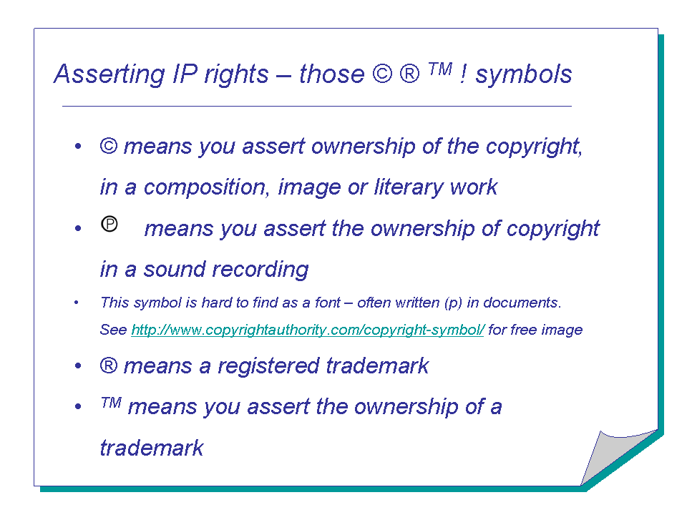

Design registration

Design registration covers the whole or part appearance of a product, resulting from features including the ‘lines, contours, colours, shape, texture and / or in materials of the product itself…’ (Patent Office, 2002). Designs are protected in the UK by three legal rights – registered designs; unregistered designs; and artistic copyright.

Copyright

Copyright provides protection for the creators of original material, including literature, art, music, sound recordings, films and broadcasts. Since 1998, computer programmes and databases also come within its scope. Copyright confers two basic rights:

- A moral right by which the authors (or copyright owners) are entitled to ensure that any use of their work is faithful to the original.

- An economic right for their effort to make sure they are paid for the use of their work.

Copyright protection is automatic as soon as there is a record, in any fixed form, and exists for 70 years (since 1996).

e-tivity (5): Business formation & controlling your IP

Part 1: Business formation

Decide on your preferred route to market entry. Will you be setting up a new venture from scratch, buying an existing business, or entering into a franchise agreement?

Use this checklist to help you choose your appropriate form:

Checklist – Legal Form

Company

Liabilities: Limited liability. Personal guarantees can reduce limitations
Records and accounts: Legal auditing and accounting requirements. Records held at Companies House
Setting up: Formal registration procedures – but can buy off the peg
Raising money: Wide choice, including equity investment
Selling up: Flexible
Status: Possibly higher perceived status
Tax, NI and pensions: Employee status PAYE, high National Insurance but full benefits. Company contributions on pension. Corporation tax on profits. Losses retained in company

Sole trader

Liabilities: All assets are liable (no separation between individual and business)
Records and accounts: No strict accounting or audit requirements. No public records
Setting up: Registration as self-employed
Raising money: Options limited to overdraft or loan
Selling up: Can only sell assets
Status: Possibly higher perceived status
Tax, NI and pensions: Insurance cheaper but fewer benefits. Tax deductible pension contributions restricted. Losses can be offset against tax on other income

Partnership

Liabilities: Liability extends to business debts of other partners
Records and accounts: As for sole trader
Setting up: As for sole trader – except partnership agreement is vital
Raising money: Overdraft, loans or new partners money
Selling up: As for sole trader
Status: As for sole trader (except in professional partnerships)
Tax, NI and pensions: As for sole trader

Part 2: Controlling your IP
How will you protect your intellectual property? Write down your approach - this could relate to IP that has already arisen or may arise in the future operation of your business. You need to think here in terms of trade marks including business names, logos and domain names, patents, copyright and designs.

Implementation Step 5: Further links & reading

Stokes, D., Wilson, N., and Mador, M. (2010) Entrepreneurship, Cengage Learning, Chapters 5 and 12.

Stokes, D. and Wilson, N. (2010) Small Business Management and Entrepreneurship edition 6, Cengage Learning, Chapters 8, 9 and 10.

The Intellectual Property Office (IPO) www.ipo.gov.uk

The Intellectual Property Portal www.intellectual-property.gov.uk

British Library Business and IP Centre http://www.bl.uk/bipc/index.html

Startups.co.uk – for buying a business and franchising advice and options

Smart.com – good information on business formats in the UK

WIPO World Intellectual Property Organisation - http://www.wipo.int/about-ip/en - offer a free handbook that covers policy, law and use of IP.

